**Life Cycle Assessment of LNG**

**IGU background and “four pillars” coverage of sustainability:**

The main role of IGU (International Gas Union) is to advocate for natural gas as an integral part of a sustainable global energy system. This is done through promoting all the Natural Gas related developments in the energy sector.

As part of the IGU efforts in advocating for Gas, 4 pillars have been identified to set their focus on the right areas. The four pillars are:

• Human resources for the future

• Natural gas available everywhere

• Natural gas for a sustainable development

• Combination with renewables and Electricity

The third pillar which is “natural gas for a sustainable development” mainly focuses on strategies that contribute to the sustainability of LNG, and development of new technologies to promote the role of LNG in the energy sector.

**Define LCA:**

Life Cycle assessment is a tool that assesses the potential environmental impact associated with a certain product by looking at the supply chain of that product and assessing it against the following frameworks:

- ISO 14040, compiling an inventory of relevant inputs and outputs of a product system

- ISO 14042, evaluating the potential environmental impacts associated with those inputs and outputs

- ISO 14043, interpreting the results of the inventory analysis and impact assessment phases in relation to the objectives of the study.

Life Cycle assessment is done through two different types of studies:

1. Attributional LCA: looking at all environmental impacts of a product
2. Consequential LCA: Describing the environmental consequences of different courses of action taken during the life cycle of the product.

**Benefits of LCA:**

The benefits of Life cycle assessment is to better understand the environmental impact of a product and its effect in each step of the chain, and be able to show the competitive advantage of a certain product over another, by showing its impact on the environment.

The results of LCA include technical details of processes and recommendations to update market major players that can be applied to improve a cycle performance environmentally. With these results, suppliers, logistics, and buyers are able to determine the hot spots of the life cycle processes and practices that aggressively emit greenhouse gases. From that point, major players can improve or adapt more developed practices. Also, they can invest on research and efficient new technologies to minimize fuel combustions and venting in certain processes. For example, QatarGas and its shareholders have invested $1 billion on Jetty Boil-Off Gas Recovery project to reduce flaring during loading LNG carriers. With such project, Qatargas and its shareholders recovers about 600 thousand tonnes per annum. This recovery helped them to save volumes and reduce carbon dioxide to 1.6 million tonnes per annum.

The life cycle assessment has been used to assess the LNG supply chain, showing the environmental impact of it as compared to other fossil fuels. This has played a major role in advocating for LNG as a cleaner source of energy. With lower greenhouse gases and other emissions, and increased energy efficiency, LNG is becoming the fuel of choice in an industry that is moving towards improving environmental awareness. (See chart below for LNG supply chain)

**LNG Value Chain:**

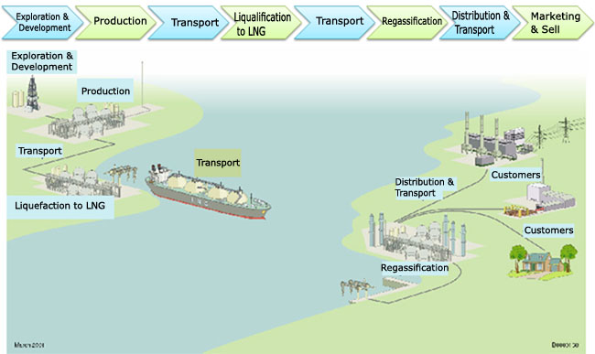

Source: OmanLNG

**How is LNG/Natural Gas competing environmentally?**

As compared to other fossil fuels, LNG is considered the cleanest and most environmentally friendly fuel, with less CO2, Sulphur dioxide, Methane, and Nitrogen oxide emissions as shown in the tables below.



**Origins of LNG:**

Back in the 1960’s, when the first LNG production units were constructed, the volumes produced were very minimal. Today, LNG facilities are 30 times larger, showing a massive improvement in technologies and infrastructure.

A plant in Arzew, Algeria, was the first to make commercial shipments, sending gas to the UK in 1964. The plant (Arzew) had a total nameplate capacity of around 0.85 million tonnes of LNG a year. This was produced by three separate production units – LNG trains – where each train had a capacity of about 280 million tonnes /year.

Going back to the history, the discovery of LNG was initiated by experiments done on the properties of LNG starting early in the 19th century, when a British scientist Michael Faraday experimented with liquefying various gases, including natural gas. A German engineer “Karl Von” built the first practical compressor refrigeration machine in 1873, in Munich. In 1912 the first LNG plant was built in West Virginia and started operating in 1917. The first commercial liquefaction plant was built in Cleveland, Ohio in 1941. In 1959, the world’s first LNG tanker, “Methane Pioneer” carried a cargo from Lake Charles, Louisiana, to Canvey Island, UK.

In 1964, the UK became the first commercial importer and Algeria was the first commercial exporter, as LNG trade between the two countries starts. From 1969 till today Japan has been the largest LNG importer and consumer. Japan’s first LNG cargoes were supplied from a plant in Alaska, USA. After a few years in 1999, the western hemisphere’s first liquefaction plant came on stream in Trinidad and Tobago. In 2011, and until today Qatar has been the largest LNG exporter in the world, with the completion of their fourth production train, generating a capacity of 77 million tonnes a year.

**LNG Players:**

The Global LNG supply dynamics are changing rapidly with the evolvement of the industry. This partly is because of technological advances that the latest LNG trains production units within an LNG plant are nearly 30 times the size of the first ones, constructed in the 1960s in Algeria. LNG ship size is also increasing, generating additional economies of scale. Many of the technological increases have occurred in Qatar, which has made the most eye catching additions to global LNG supply, rapidly building its capacity to a world leading 77 million tonnes a year in 2011.

But the recent studies by EnergyFuture.com say that Qatar may soon be overtaken by Australia, wich will be account for most of the growth In supply in the next five years. In addition to a few other countries that are set to emerge as important LNG suppliers, including Mozambique and Tanzania, in east Africa and the US.

According to the International Energy Agency, global gas liquefaction capacity amounts are over 280 million tonnes a year, about a third more than five years ago, when it was 208 million tonnes a year.

**Historic Timeline:**

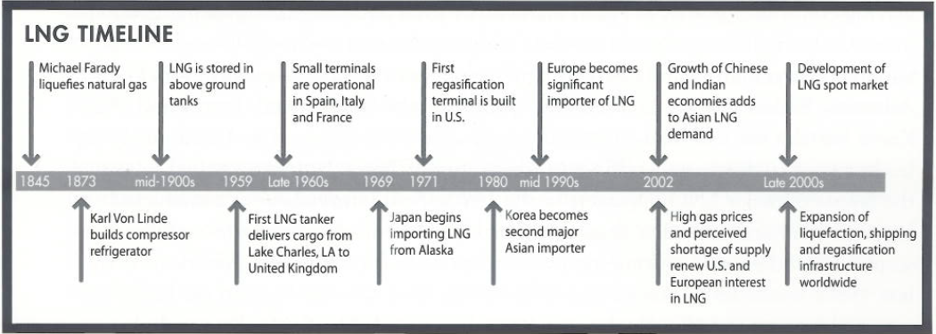

Source: Understanding Today’s Global LNG Business.

**LNG safety:**

The LNG industry has an excellent safety record, as a result of several factors. First the industry has been developed to ensure safe and secure operations, from engineering to technical competency of personnel. Second, the physical; and chemical properties of LNG are well understood and the plants designs are well proven through many years of operation. Third, the standards, codes, and regulations that have been developed for the LNG industry ensure safety and are continuously evolving and improving.

LNG facilities can be located above ground. Operators and owners have many more opportunities for locating LNG facilities in comparison with traditional underground gas storage alternatives that depends on underground geological conditions such as depleted tanks, aquifers, and salt caverns.

Through the years, LNG has an excellent safety record, due to strict industrial safety standards applied worldwide. Up to 2012 there have been some 50,000 LNG carrier trips, without a significant accident or safety problem, either in the port on in the high seas.

**Supply Chain:**

The supply chain includes all the facility and equipment involved in taking natural gas from underground reservoir, liquefying it, and transporting to an end user customer of natural gas.

The supply chain is typically long in terms of distance and expensive in terms of the capital sots of the equipment and facility involved. The components of the supply chain typically include:

* Gas field production infrastructure
* Feed gas pipeline to gas processing and conditioning plant
* A large scale refrigeration plant involving heat exchanges to liquefy the feed gas
* LNG storage and port loading facilities: everything must kept cold
* LNG marine tankers
* LNG receiving terminal including port uploading, LNG storage, regasification, and gas send out compression facilities
* Connection to natural gas transmission and distribution network to deliver gas to customers
* Sometimes, distribution of LNG by truck to small, remote off grid gas customers

**LNG competing against other fuels:**

LNG is gaining market share from other hydrocarbon resources at expense, while coal is fighting back, renewable fuels are supporting the change of energy mix, and nuclear is showing signs of life. Expectations for the potential of renewable fuels associated technologies are often overstated, and reducing coal’s environmental impact is not small undertaking.

**Overview discussion of LNG Chains:**

Schematics of LNG industry:

The term LNG refers to Liquefied Natural Gas, which is Natural Gas that cooled down and converted into a liquid state. This is done to facilitate the process of transportation, and to be able to deliver larger quantities.

The demand for LNG has grown rapidly since the 1980’s, this is mainly because of its environmental advantages over other fossil fuels, in addition to its price competitiveness, and efficiency.

The LNG industry operates through a supply chain that comprises of three main components; Upstream, Midstream, and Downstream. An additional attribute that contributes to the flow of the LNG supply chain are services offered by third parties to facilitate the process.

**LNG Industry:**

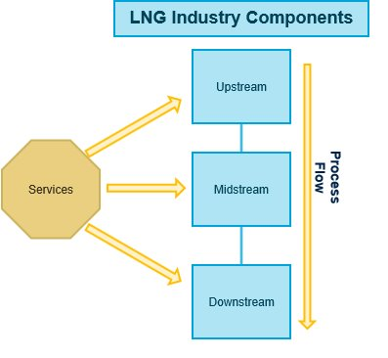

LNG Process Diagram

**Upstream:**

Upstream activities comprise of the exploration and production of natural gas to feed the liquefaction process. The discovery and drilling for natural gas are done by major international players in the energy sector who can also subcontract to service companies.

**Midstream (can also be included in Downstream):**

LNG shipping and logistics of delivery are administrated in this stage. The main method of LNG transportation method at this level is LNG vessels that come in different classes with different volumes capacity (Conventional, Q-max and Q-flex). Depending on the type of LNG agreement, LNG delivery can either be Free on Board (FOB) shipping method, where the seller’s responsibility to deliver terminates at their premises once the vessel is loaded. The other delivery method is delivery Ex Ship (DES), where the seller is responsible to deliver to the buyer’s regasification Terminal.

**Downstream:**

Once the LNG is delivered to the buyer, it has reached the downstream level. At this stage the LNG is re-gasified to its original state, which is natural gas at the regasification terminal and then distributed to customers that will sell it to the end-users.

**Services:**

During the lifecycle of LNG production and distribution, certain services are required to ensure that the process runs smoothly. These services include support to the process (products, Machinery…etc), maintenance and technology support, which contributes to the reliability and sustainability of the process.

**Traditional international trade:**

Traditional International LNG trade is mainly trades done through long term Sales and purchase agreements. This is to ensure security of outlet and revenue to LNG producers who are looking to make an investment in a liquefaction plant. There are different types of LNG producers/exporters including NOC’s, IOC’s or joint ventures.

Other types of trade include spot and short term trades that come from uncommitted volumes or optimized long term contracts. Recently, reloads has picked up mainly in Europe due to excess supply in the region.

In terms of pricing, long term volumes prices are typically oil linked, when applicable a hub indexation is applied (i.e.: UK market). However, recently we have been seeing some hybrid formulas that include oil and hub indexation at the same time.

**Chain descriptions from the World LNG report:**

The LNG value chain starts with the liquefaction process of natural Gas, followed by shipping it to different markets using an LNG carrier. Once the LNG reaches the target market, it is regasified back to the original state and consumed in the power industry, or distributed as natural gas. (See chart below from World LNG Report-IGU)

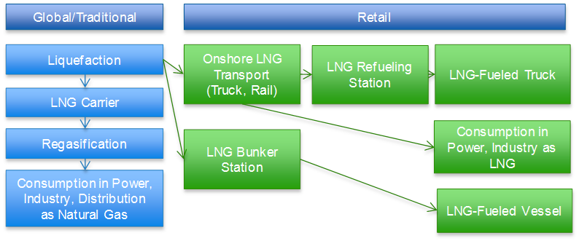

Source: IGU

**Land-based facilities and technologies at this time:**

Land based liquefaction Facilities are the most common in the LNG industry. They are onshore facilities that liquefy natural Gas (Feedgas) produced either onshore or offshore (transmitted through pipelines to the onshore facility in the case of offshore production).

**Current chains not covered (e.g. FSRU, FLNG); maybe covered in future studies:**

Floating LNG terminals which are water based are a new technology of liquefaction done offshore to facilitate the development of offshore natural gas resources.

**Natural gas and LNG competitive advantage:**

Comparison and environmental advantage:

In power generation, Coal has been always the traditional source due to its availability, cost, and simplicity to use. With the emergence of oil, suppliers and buyers favor oil because of its natural state. Oil being liquid helps users and suppliers to ship it and store it easily. With the discovery of natural gas, it became a highly demanded source of energy because it’s considered relatively cheaper and cleaner than other fossil fuels. According to The U.S. Energy Information Administration, power plants in 2002 needed 10,314 Btu from coal or 10,641 from petroleum to generate 1 kilowatt-hour. In terms of Natural Gas, in the past, power plants needed 9,533 Btu to generate a kilowatt-hour. However, with the rapid technology developments the LNG industry, power Plants were able to increase their efficiency by using 8,039 Btu to generate 1 kilowatt-hour in 2012. On the other hand, petroleum and coal plants are becoming less efficient, using 10,991 and 10,498 Btu to generate 1 Kilowatt-hour.

<http://www.eia.gov/electricity/annual/html/epa_08_01.html>

**Coal vs LNG power plants:**

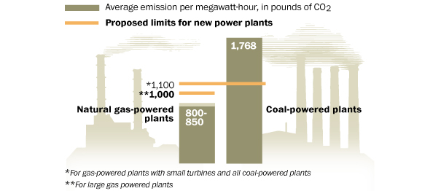

Source: The Washington Post

**Pipeline vs LNG carrier:**

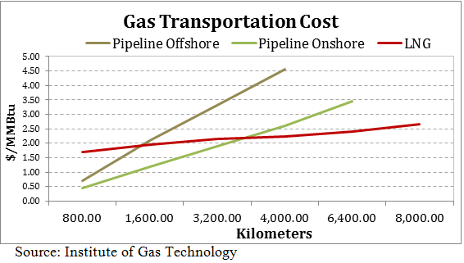The development of LNG made the process of transporting natural gas even more efficient. As the graph below shows, at a certain distance, using an LNG carrier is more efficient than a pipeline.

**Transportation Advances:**

The development of LNG made the process of transporting natural gas cleaner and even more efficient. Qatar, with the help of Samsung, Hyundai, and Daewoo advanced technologies, managed to obtain huge fleet of larger LNG volume carriers. The conventional carrier size is 145,000 mᶟ. With the creation of Q-flex and Q-max carriers, the possible delivered volume is raised to be 210,000 – 260,000 mᶟ. Moreover, the advances between the first Algerian carrier (Methane Princess) and Q-max carrier (Mozah) are much greater. The first commercial LNG carrier was in 1964 was with capacity of 27,400 mᶟ.

**Carriers Comparison**s:

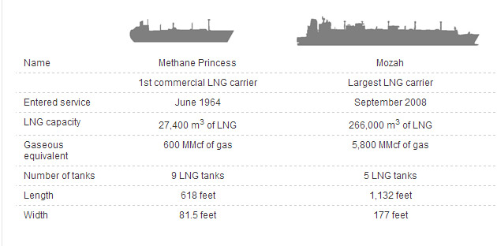

Source: Chem.Info of Advantage Media

**Today’s Commercial Carriers:**

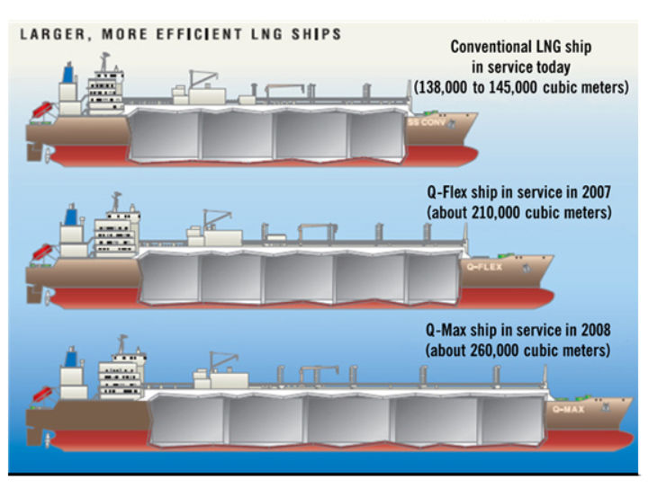

Source: International Human Resources Development Corporation

The next drive that has major effectiveness to the transportation process is the new technology that has been built in these new carriers, which assisted the reduction of CO2 emissions. The technology is known as Boil-Off Gas re-liquefaction system (Ecorel) that is delivered by Cryostar. To stop flaring and venting process on course, the carriers achieved to re-liquefy any vaporized LNG back to the tank instead of flaring and venting it.